**TEST PLAN: (‘See All Bots' button)**

**Test Case Type:**  Functionality

**Description:**  Clicking on ‘See All Bots' button should display all 10 bots

**Test Step:**  1. Go to http://localhost:3000/

2. Click 'See All Bots' button

**Expected Result:**  Should display all 10 bots

**Status:**  Success or Fail

**BUG REPORT: (‘See All Bots' button)**

**Summary:** On click of ‘See All Bots' button, there are no bots displayed.

**Screenshot:**

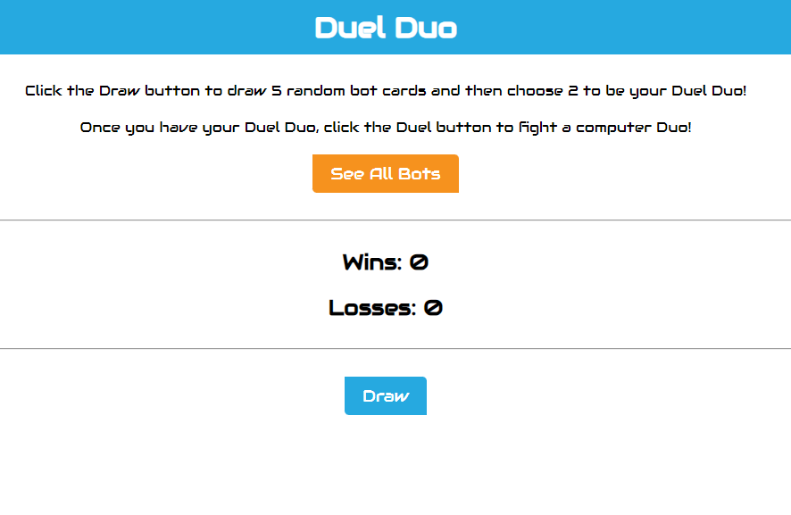

**Expected result:** See all 10 bot's details

**Actual result:** Don’t see any bot details

**URL:**  http://localhost:3000/

**Browser:** Chrome

## **BUG REPORT: (Result on winning or losing both gets added to ‘Losses’)**

**Summary:** On click of ‘Duel' button, the system determines if the user wins or loses. Insite of the user winning the duel, the point gets added to the ‘Losses’ counter.

**Screenshot:**

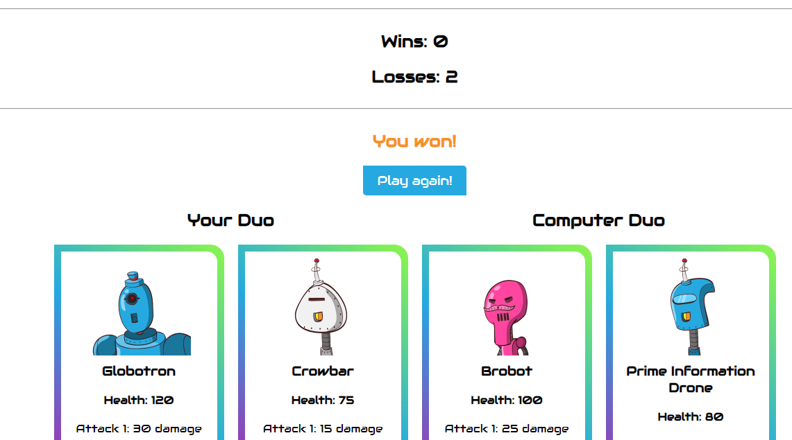

**Expected result:** ‘Losses’ 1 point gets added to the ‘Wins’ counter.

**Actual result:** 1 point gets added to the ‘Losses’ counter

**URL:**  http://localhost:3000/

**Browser:** Chrome